Exam Booking Instructions
- Log in to https://luc-accommodate.symplicity.com/
- Select Testing Room
- Select New Booking Request
- Follow the instructions at the top of the page
  - Select Course
  - Select Date
  - You do not need to change the hours
  - Select YES for the extended time calendar
  - Select Campus
  - Optional: if you are approved for specific testing accommodations, please select them in Specific Accommodation Required section (example: computer for typing, computer for text to speech, etc.)
- Available seats will populate on the right side of the screen, please be sure to select the appropriate start time!
- A confirm Exam Booking pop up will appear; please verify the details you submitted are correct!
- Select Submit Request
Step by step with screenshots
- Log in to Accommodate
- Select Testing Room
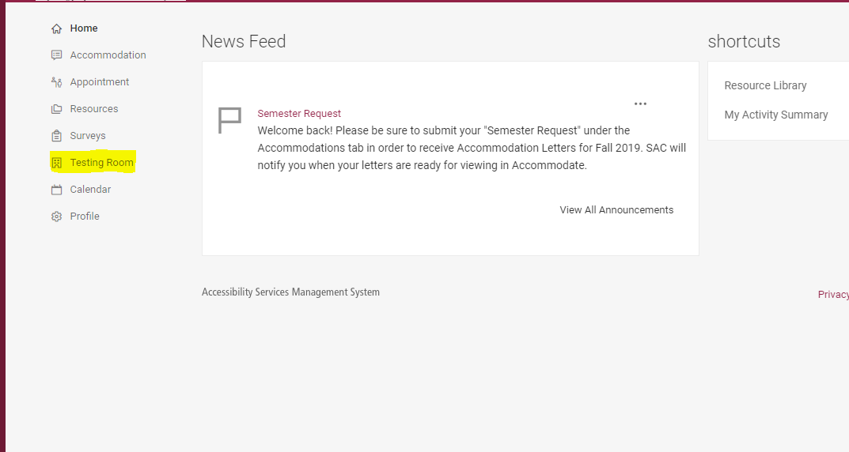
- Select New Booking Request
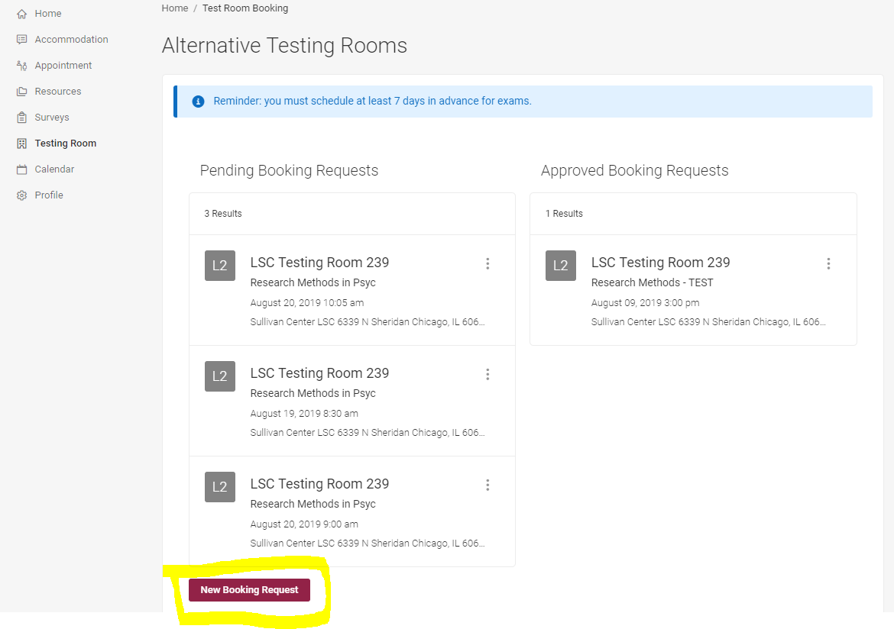

- Follow the instructions at the top of the page
  - Select Course
  - Select Date
  - You do not need to change the hours
  - Select YES for the extended time calendar
  - Select the length of the exam
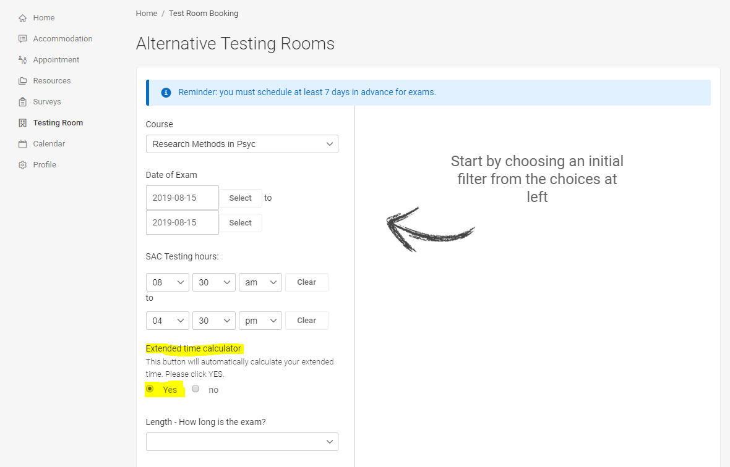

- Select Campus
- Optional: if you are approved for specific testing accommodations, please select them in Specific Accommodation Required section (example: computer for typing, computer for text to speech, etc.)
- Available seats will populate on the right side of the screen, please be sure to select the appropriate start time!
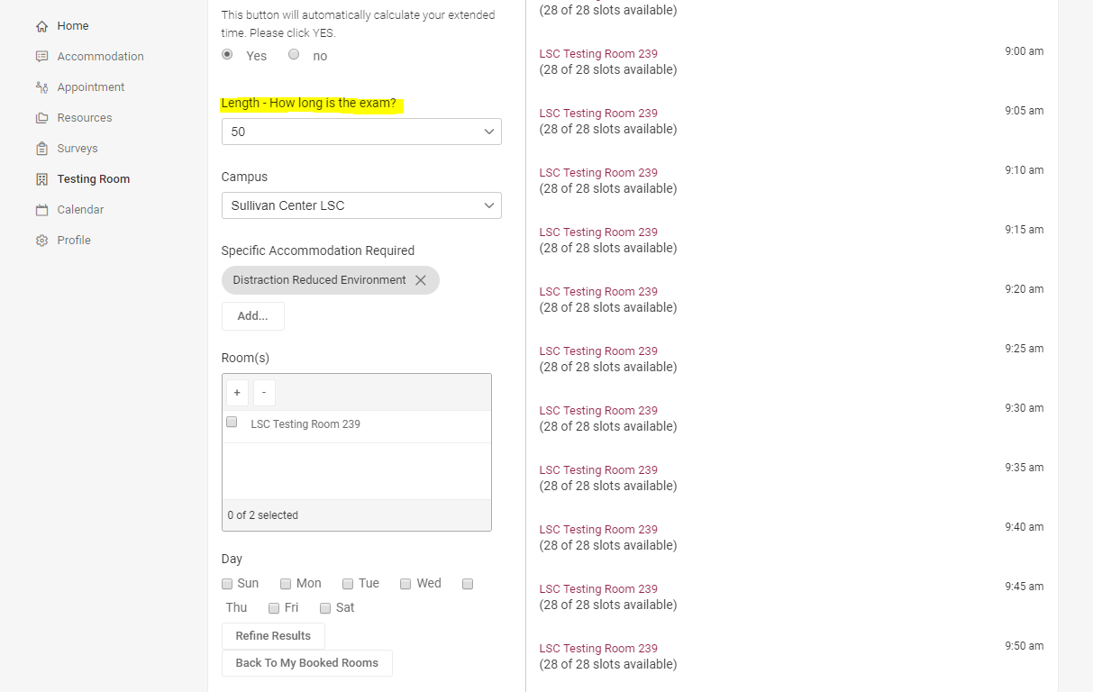

- A confirm Exam Booking pop up will appear; please verify the details you submitted are correct!
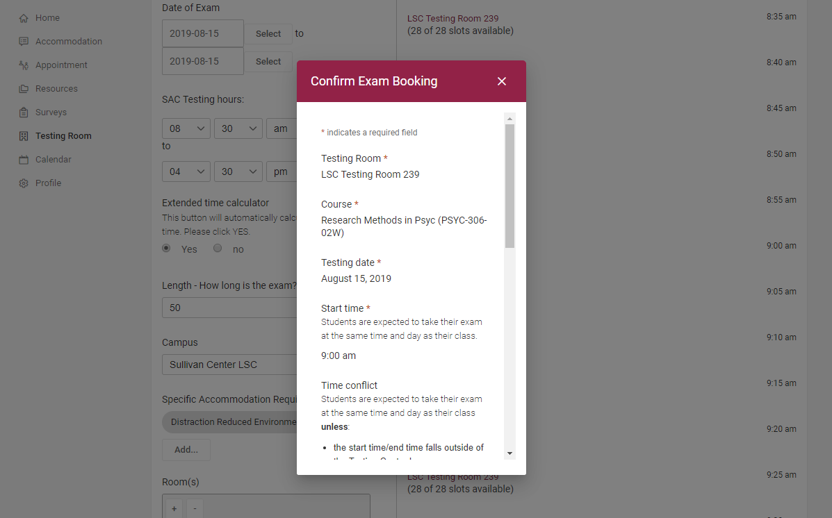
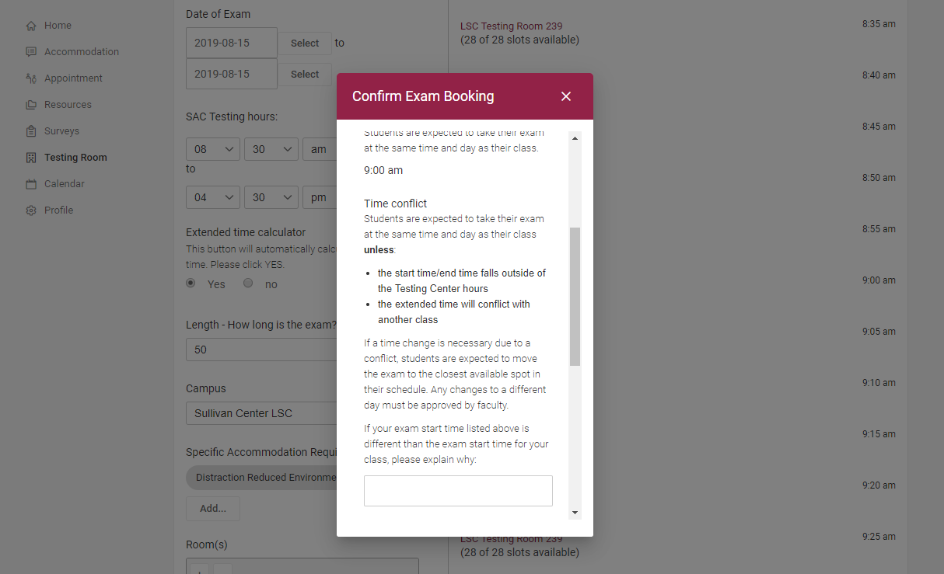

- Select Submit Request
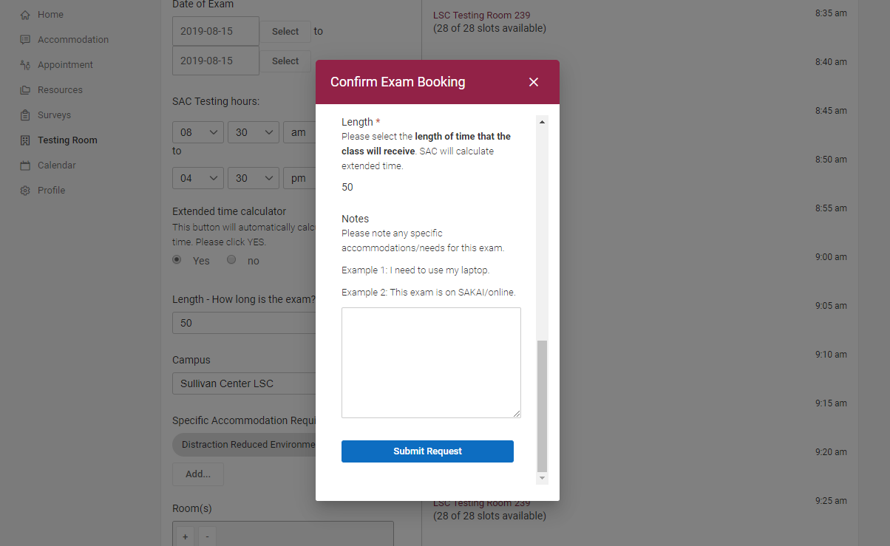

Please reach out to the Student Accessibility Center with any questions regarding exam booking.

Student Accessibility Center
Sullivan Center for Student Services, Suite 117
(773) 508-3700
sactesting@luc.edu

